Admissions Policy Lillian de Lissa Nursery School

2023 -2024

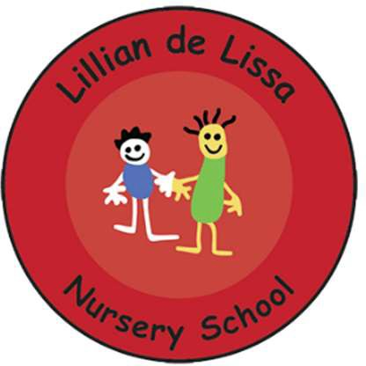

The Birmingham Federation of Maintained Nursery Schools follow the policies and procedures from Birmingham City Council and Birmingham Safeguarding Children Board (BSCB) which includes the Government's Prevent Strategy.

Two Year Olds
Criteria for identifying which children are eligible for a two year old funded early education place:
- Universal credit.
- Income support.
- Income-based Job Seekers' Allowance.
- Income-related Employment and Support Allowance (If you are unable to work due to illness or a disability).
- Support under Part VI of the Immigration and Asylum Act 1999.
- The Guarantee element of the State Pension Credit; or Child Tax Credit, provided they have an annual gross income of no more than £16,190 as assessed by Her Majesty’s Revenue and Customs (HMRC).
- Working Tax Credits (including those in receipt during the four-week period immediately after their employment ceases, or after they start to work fewer than 16 hours per week) with a household income of less than £16,190 as assessed by HMRC.
- The child is looked after by their local authority.
- The child who has left care through special guardianship or an adoption or child arrangements order.
- The child has a current Education, Health and Care plan.
- The child is entitled to Disability Living Allowance.

Start dates for two year olds:
  - To start in September children must have their second birthday before 1st September.
  - To start in January children must have their second birthday before 1st January.
  - To start in April children must have their second birthday before 1st April.

Three Year Olds
At Lillian de Lissa Nursery School we offer places on a part time basis – All day, Monday, Tuesday and Wednesday morning OR Wednesday afternoon, all day Thursday and Friday. (With the exception of those who are entitled to 30 hours childcare)
15 hours Entitlement
The current regulations require local authorities to ensure free provision is available from the start of the term following a child’s third birthday, for no fewer than 38 weeks in any year; and for 15 hours in respect of each of those 38 weeks.

Start Dates
To start in September children must have their third birthday before 1st September. To start in January children must have their third birthday before 1st January.
To start in April children must have their third birthday before 1st April.

30 Hours Criteria
A child is entitled to 30 hours childcare the term after their third birthday or from the term after their family becomes eligible. ; Parents will need to confirm that they remain eligible every three months. The eligibility criteria is set out below.

- The parent of the child (and their partner where applicable) should also be in qualifying paid work. The definition of qualifying paid work is each parent or the single parent in a lone parent household will need to expect to earn the equivalent of 16 hours at the national living wage or their national minimum wage rate over the forthcoming quarter. This applies whether you are in paid employment, self- employed or on zero hours contract.

- Where one or both parents are in receipt of benefits in connection with sickness or parenting, they are treated as though they are in paid work.

- Where one parent (in a couple household) is in receipt or could be entitled to be in receipt of specific benefits related to caring, incapacity for work or limited capability for work that they are treated as though they are in paid work.

- Where a parent is in a ‘start up period’ (i.e. they are newly self-employed) they do not need to demonstrate that they meet the income criteria for 12 months in order to qualify for the extended entitlement.
- If either or both parents’ income exceeds £100,000 they will not be eligible for the extended entitlement.

Parents/ carers can also ‘top up’ the hours the child attends. This is subject to fee paying and availability. Please contact the school directly for further details.

We do not admit children of Reception age to our setting but we will work with families to support their application for a suitable school place for their child.

See https://www.childcarechoices.gov.uk for further information on your childcare entitlement.

Date Policy Adopted:
Local Committee: 5.6.2023
Full Governing Board: 26.6.2023
Date for next renewal: Autumn Term 2024

Signed: ____________________________ Sue Sidaway
Chair of Local Committee

Signed: ____________________________ Sean Delaney
Chair of Governors

Signed: ____________________________ David Aldworth
Executive Head Teacher

